How to show page breaks in Google Sheets

In Google Sheets, page breaks are markers that determine where a new page begins when printing a spreadsheet. They help control the layout and appearance of printed sheets by defining the boundaries between pages. Page breaks allow you to have better control over how your spreadsheet content is distributed across multiple pages when printed. By visualizing the page breaks, you can ensure that important data or headers are not split between pages, making it easier to read and understand the information.

The provided dataset consists of product names and their corresponding sales data for various months from January 2010 to May 2012. This is a very large data and let’s consider that you’re a financial analyst and want to analyze this data and also print this data. In this tutorial we will learn how to control the layout and appearance of printed sheets by defining the boundaries between pages by using page breaks.

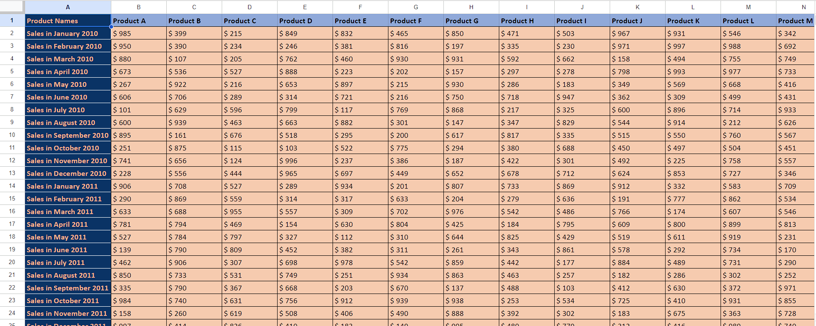

## Step 1 – Open the Print Settings in Excel

* Open your Google Sheets spreadsheet in your web browser.
* Click on the "File" menu located at the top-left corner of the screen.
* From the drop-down menu, select option named "Print."
* This will open the print settings window and print settings side bar will be present on the right side of the screen.
* Alternatively, you can do this by using “Ctrl+P” shortcut key.



## Step 2 – Select the Orientation of Page

* In the print settings sidebar, you can adjust various options, such as selecting the printer, choosing the paper size, setting the orientation (portrait or landscape), adjusting margins, and specifying the number of copies.
* From these options, select the orientation of page.
* If you want to cover more columns data then select “Portrait orientation”.
* If you wish to have more rows data then select “Landscape orientation”.
* Also select the size of sheet on which you want to print the data.



## Step 3 – Set Custom Page Breaks

* After selecting the orientation, click on the “Set Custom Page Breaks” just below the “Margins” option.
* After you click “Set Custom Page Breaks”, you should see dotted lines indicating the page breaks.

Horizontal page breaks are represented by dashed lines between rows.

Vertical page breaks are represented by dashed lines between columns.

* If you don't see the page breaks, ensure that your spreadsheet is large enough to require multiple pages when printed. If your spreadsheet fits on a single page, page breaks may not be visible.
* You can adjust the zoom level of the preview by clicking on the plus (+) or minus (-) buttons in the lower-right corner of the screen and adjust the vertical and horizontal page breaks according to the area you want to print in one page.
* After you’ve set the page breaks, click on the option named as “Confirm Breaks” and then you can print the page.

